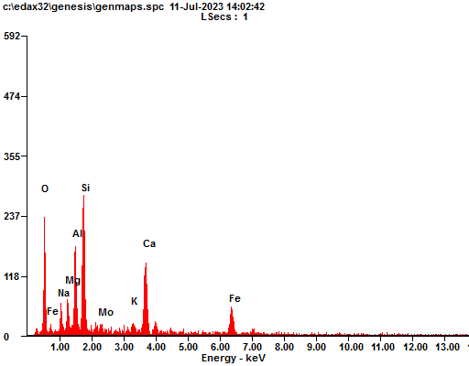
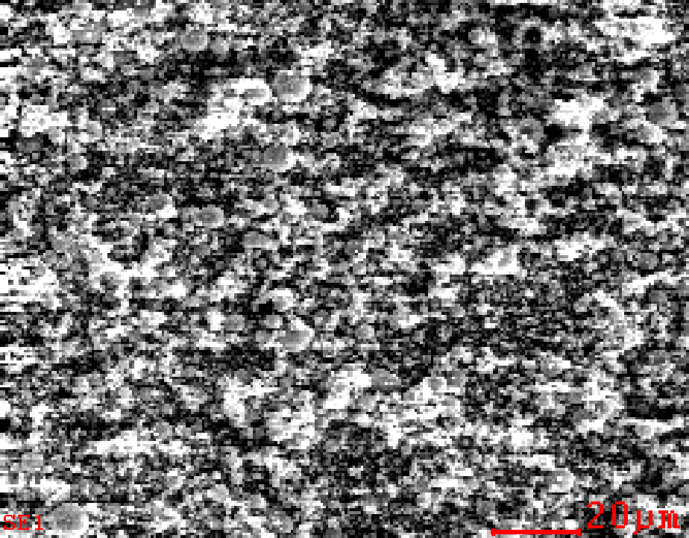
Element | Wt% | At%
OK | 33.51 | 51.07
NaK | 04.56 | 04.84
MgK | 04.24 | 04.26
AlK | 10.76 | 09.73
SiK | 17.50 | 15.19
MoL | 02.21 | 00.56
KK | 01.72 | 01.07
CaK | 12.57 | 07.64
FeK | 12.92 | 05.64
Matrix | Correction | ZAF

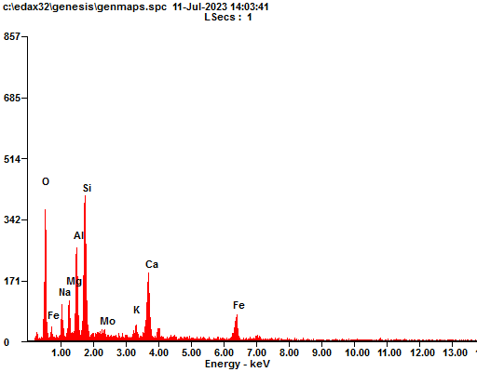
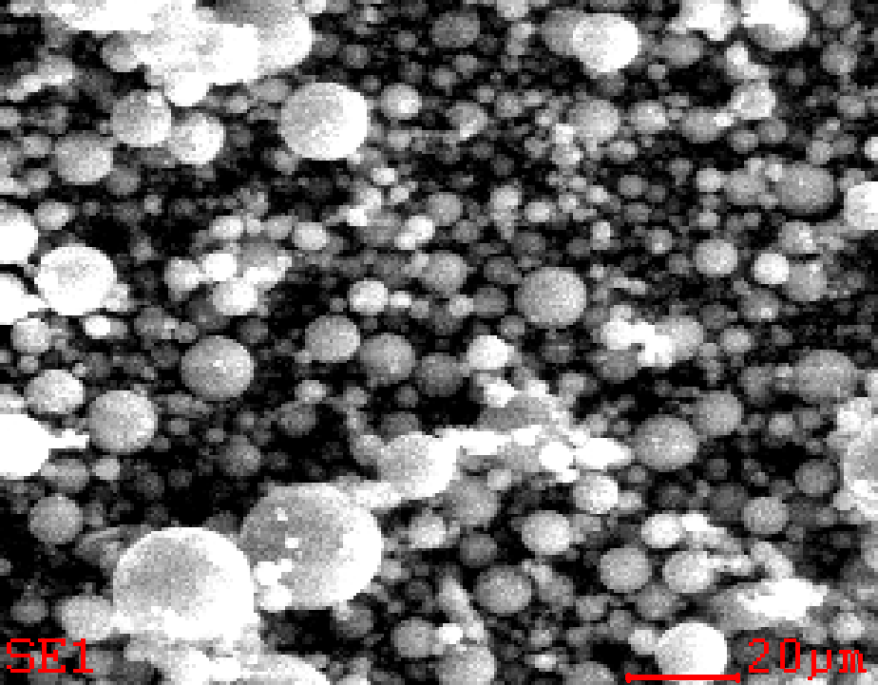
Element | Wt% | At%
OK | 35.29 | 52.57
NaK | 04.73 | 04.90
MgK | 04.58 | 04.49
AlK | 11.32 | 10.00
SiK | 17.67 | 14.99
MoL | 02.09 | 00.52
KK | 01.80 | 01.10
CaK | 10.88 | 06.47
FeK | 11.63 | 04.96
Matrix | Correction | ZAF

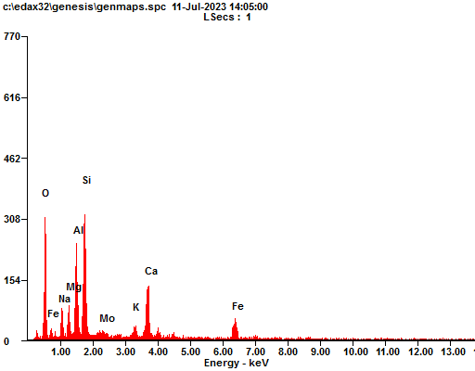
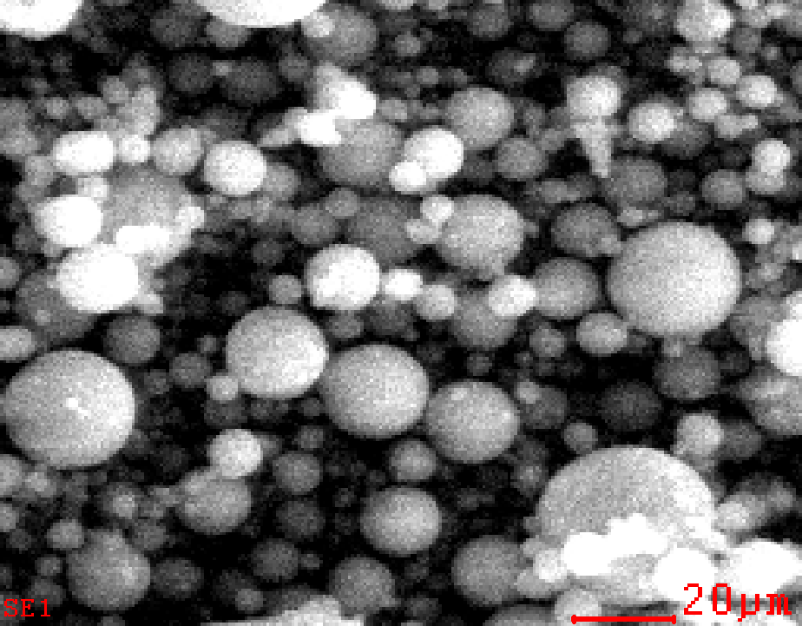
Element | Wt% | At%
OK | 35.68 | 52.65
NaK | 04.74 | 04.87
MgK | 04.38 | 04.26
AlK | 11.58 | 10.14
SiK | 18.61 | 15.64
MoL | 01.37 | 00.34
KK | 01.80 | 01.09
CaK | 10.78 | 06.35
FeK | 11.05 | 04.67
Matrix | Correction | ZAF

